**Build on Concepts (BoC) Site Report 3  
Student Name: Ronniel Dizon  
Date: 14-OCT-2018**

**Website URL: http://cis2.oc.ctc.edu/class/ag155.fall18/ronnieldizon/BoCs/BoC3/home.html**

Use the check list below to work through the tasks for BoC3. Note that line numbers or other indications are *required* and points will be deduct if they are not present (since if you don’t tell me where to locate the item, it may not be done).

Also complete the section after the checklist showing your validation, site URL, and screen rendering of your site.

Do not upload this file to cis2; only submit it to Canvas.

|  |  |  |
| --- | --- | --- |
| **Check if Done** | **Task** | **Where in the code is it found (line number or other indication) – use NA if not applicable, add notes if consideration is needed.** |
| **Set up your BoC3 site root and a new page to code:** | | |
|  | Copy all the files from your BoC2 site root directory on your local system into the BoC3 site root directory on your local system. Make sure you are working with a copy of the original BoC2, not pointers to those files. Your original BoC2 should remain as is. You will work with a fresh copy of the files. |  |
|  | Open **home.html and the two HTML file you created** for previous BoCs. You will modify all of them. | Modified home.html slightly to incorporate the marquee effect. |
|  | Create or use a link on the left-side navigation as the topic for a new page that you will develop (not the existing home or contact/about links). |  |
|  | In your text editor create a new HTML file from scratch to add to your local site, and save it as an HTML file to the BoC3 site root. You can name it whatever makes sense to you; just be sure it has no spaces, and preferably uses only lower-case characters. Make sure it uses the html file extension. | media.html |
|  | Create the basic structure of an HTML document that includes properly-nested elements for head and body, and declares the doctype for HTML5. Code at least 3 meta elements and a title that reflects the new page. Make sure that the head and body are nested within the html tags (don't forget your closing html tag) and that all head content is complete. |  |
|  | Link your new html file to the two CSS files (sb.css and sbstyles.css) – do not modify sb.css. | Also added MediaStyles.css and marquee.css. All new content are in these css files. |
|  | Be sure your name and the date are in the comments at the top of the document. |  |
|  | Duplicate the nav and header content onto your new page (do not confuse header and head--header is part of the page body that appears at the top of the page in the browser). You can do this by copying the top part of the body code from the top of the nav to the bottom of the header (the same as you did for BoC2); you want to capture all page elements that pertain to the top of the page so that there is consistency on the pages. Make sure you do not copy any other page content. Paste this at the top of your new page just under the opening body tag. |  |
| **Generate new content:**  For this assignment, you will refer to an existing wireframe, and you will do your best to use it as your guide for coding the page. It is not unusual for developers to work with other designers'/clients’ site ideas and layout. The wireframe depicts layout elements and background colors for new parts of the page. Using your best coding practices, do your best to produce a representation of the wireframe. Reproduce the general layout areas as shown. Download and view the PDF document provided in the Canvas shell, as you will use this wireframe as a reference for the instructions below.  If you submitted a modified wireframe proposal in Module 6, that may be used instead. | | |
|  | Based on the topic of your selected page, generate content for the page that includes text and images. You can generate the content, or copy content with an appropriate citation.  Just as with BoC2, refer to the content collection writeup for information on how to appropriately re-use others’ work. You are not being graded on your content writing skills, but rather only on your coding skills. Using other people's written work should always be taken seriously and credit given, even if used under educational fair-use rules or available in the public domain. |  |
| **Add new content, structure, and styles to the new page:**  The content and structure are achieved within the HTML of your new page. The styles are achieved within the CSS.  When adding styles to the CSS document, clearly indicate where this page's styles are coded. Do not modify the page header or nav with your new styles; also, be mindful that newly added selectors for this page do not inadvertently override any of the styles for the previous pages. In other words, be watchful for conflicting styles. Use the developer tools as needed to help you find which styles the browser is using.  If you submitted a replacement wireframe, note in the Notes how you altered these steps if that was required given your replacement wireframe. | | |
|  | Create the structural layout:  Using the wireframe as a guide, create your structural layout areas. Notice that there are six areas within the main part of the page: page header, columnar content, a form, a horizontal grouping of items (could be images or something else you wish to show), a table, a page footer.  Refer to the wireframe as you build the structure of the page:  Add new section element for your new page below the header into which you will nest the structural areas. All content will be nested in this section. |  |
|  | Nested within the section, add a heading element (h1 through h6 -- you can choose) that occupies the top of the section. |  |
|  | Nested within the section, add an article element that appears just under your newly-added header. |  |
|  | Nested within the section, add a form element that follows the article. You will make it so that the form appears on the right side of the article, per the wireframe (or appropriate to your proposed wireframe). |  |
|  | Nested within the section, add another section that will become a flex container for the horizontal items. | N/A |
|  | Nested within the section, add a table that appears below the flex container section. |  |
|  | Nested within the section, add a footer element that appears at the bottom of the section. | Line 81 |
| **Add content and style to each of the six parts:** | | |
|  | **1. Heading**: Add text that reflects your page's topic, and style the heading any way you wish with font, color, borders, or anything else you like. Make sure that it occupies the appropriate space per the wireframe. | media.html: Line 43;  styles.css: Line 58 |
|  | **2. Article (this writeup is based on the provided wireframe; your requirements may differ if you had a wireframe proposal accepted)**:   * The article box needs to occupy 2/3 of the section, and should sit on the left under the section heading. * Add a background color that approximates what you see in the wireframe. * Populate the article with text content that overfills the article, and make it so that the extra content creates a scroll bar. The height of the article must stay true to the wireframe. The scroll bar will allow for overflow. * Create two or more columns using the text inside of the article (see suggested column styles further below). * Provide sufficient content to show your design is working. | media.html: Line 51  MediaStyles.css: Line 22 |
|  | **3. Form**: Create a container as a placeholder for a form, which will be completed in the next module. You can use a figure box with width and height dimensions or something else to give this part of the page some structure. | media.html: Line 82  MediaStyles.css: Line 74 |
|  | **4. Flex Container Section**:   * Make a flex container from the section that is child of the page’s main section. * Nest three or more elements within the section that will become your flex items. * Populate them with content of your choosing, such as images, special characters, shapes, graphics, and/or text. * Design the flex container to suit your needs so that it shows the content well. * Stay true to the wireframe, but feel free to add features and designs that you want to make it look nice. | N/A  (will need some refresher on how to do this) |
|  | **5. Table**:   * Think of a reason to have a table, such as listing events or temperatures, whatever seems interesting and relevant data for your site. * Create a table that uses the appropriate number of rows and columns to represent your idea. * Populate the table with data. * Format the table (in the CSS) to present it nicely.   Note both the location of the table in the HTML and of its related CSS in the CSS file. | Media.html: Lines 107, 161  MediaStyles.css: Lines 34, 161 |
|  | **6. Footer**:   * The footer needs to occupy its own line at the bottom of the section (use a clear style as needed so that the footer does not float). * Add text that seems appropriate for the site and that reflects this page's topic. * Style the footer any way you wish with font, color, borders, or anything else you like.   Note if you chose to carry this footer onto the other pages or not in the notes to the right, as well as its location in your new file. | Not really sure if it counts as a footer, but I put the clip of Barney saying “I Love You” |
| **Finish coding the site:** | | |
|  | In all the HTML documents, create hyperlinks in the navigation that point to the new page. All navigation links should be working on all pages the same way. Note how that was done in the box to the right. |  |
|  | Verify that your code is structured and formatted to properly reflect the nested environment. Note how that was done in the box to the right. | Refer to wireframe. |
|  | Verify that ALL links are working to reflect the new site’s references and sources. Note how that was done in the box to the right. | No invalid media or bad links |
|  | Verify that your newly added styles did not clobber any of the styling from previously created pages—fix any issues you find. Note how that was done in the box to the right. | Created MediaStyles.css. |
|  | Create comments that indicate where your new styles are added in--use your best judgement and make the comments meaningful and helpful for following your code in the CSS. Be sure your name is in the comments at the top of all coded pages. Note how that was done in the box to the right. | [media.html] Added notes indicating adding MediaStyles.css.  [home.html] Added a note after linking marquee.css. |
|  | Validate your HTML and CSS using w3c’s validators. Note that even invalid HTML/CSS may still render “correctly”, but the code itself also has to be valid. Provide screenshots of validation of your new page(s) and your modified CSS file below this table. Note there should not be any validation errors, and contact me about any warnings to see if they should be cleared up. | Provided below |
|  | Once you upload to CIS2, make sure no files are missing or misnamed (case matters!) by testing all pages and links within them. Include the URL and screen shots of your pages (including the browser address bar) below. | Provided below |
|  | Test your code in several browsers to make sure it renders correctly. Note any particular browser issues in the box to the right. | Provided below |

This is another long list of tasks, but each task is small. Process through the list step-by-step. All tasks are derived from the module readings and practice. If you are unsure how to do one of the tasks, move on and come back to it later. You will find these tasks covered in the module material. Ask for help as needed. Be sure to comment well to ensure your work can be properly graded!

Congratulations on producing your first web site!

# Validation Screen Shots:

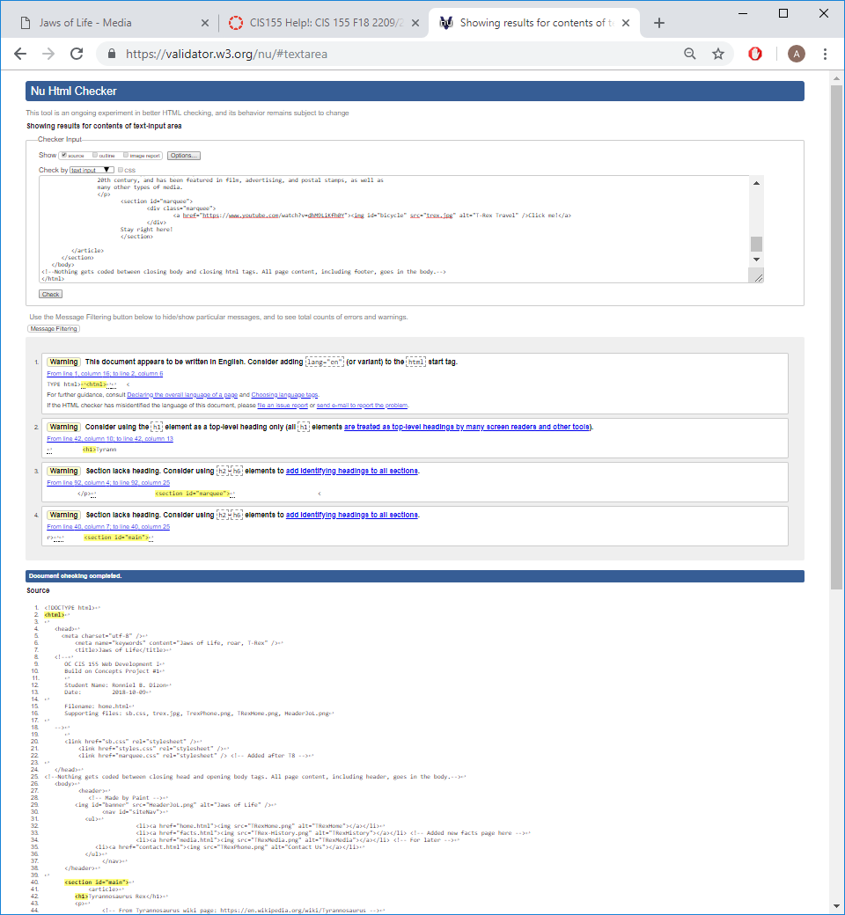

home.html after adding marquee effect.

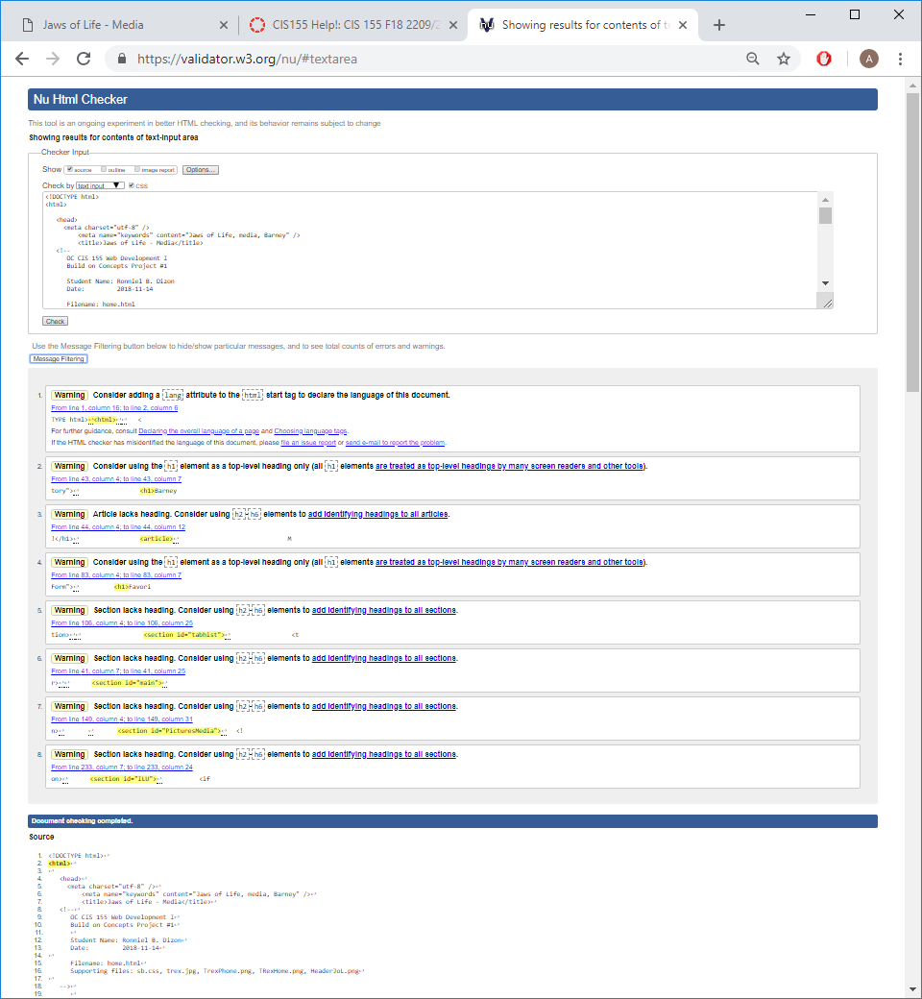

media.html

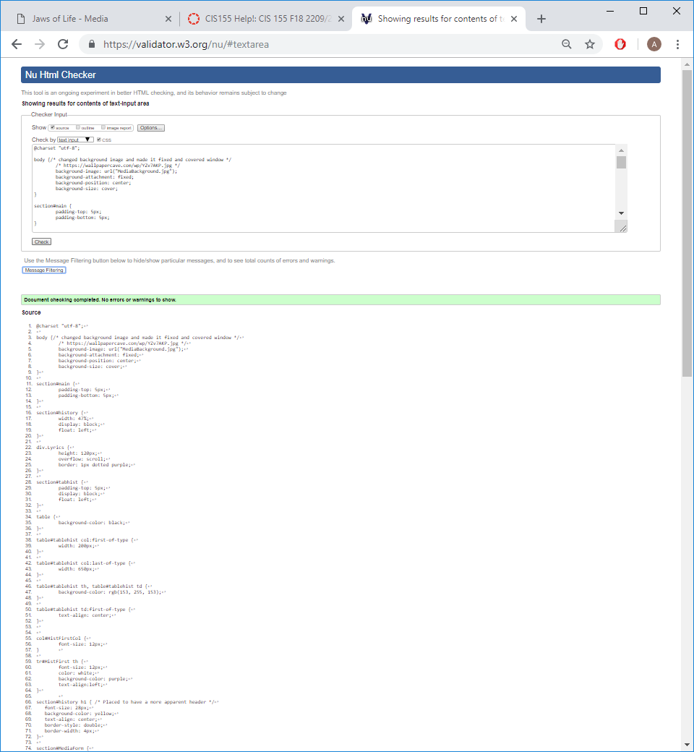

MediaStyles.css

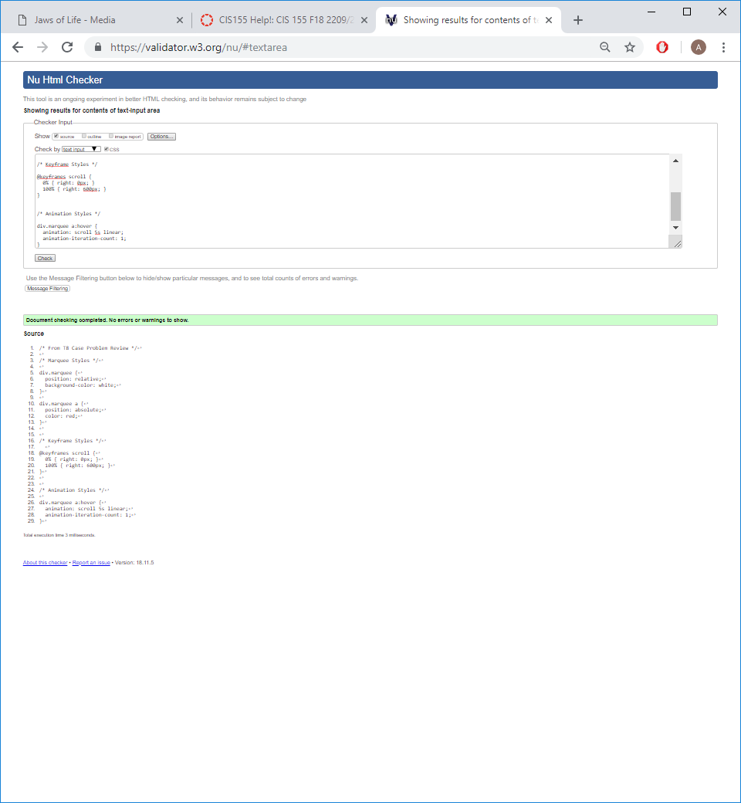

marquee.css

# URL to your site:

Complete this URL with your cis2 home page for your BoC1 submission. This is the address you type in to the browser to get to your site’s home page. Note, you won’t be able to “drill down” from the cis2 class page since you secured your home directory with an index.html file. You must construct this URL by adding your folders and the home page file name to your personal URL on cis2.

http://cis2.oc.ctc.edu/class/ag155.fall18/ronnieldizon/BoCs/BoC3/home.html

# Rendered Site Screen Shots:

Add screen shots of your rendered site here; these need not be the “full page”, but should show the full browser window with the URL visible in the browser’s address bar, and the top portion of the page typically visible in a standard PC layout.

Include screen shots of all pages added or altered since BoC2. If an existing page’s source HTML or CSS have changed, a screen shot is needed, even if the CSS file is a separate file from the HTML.

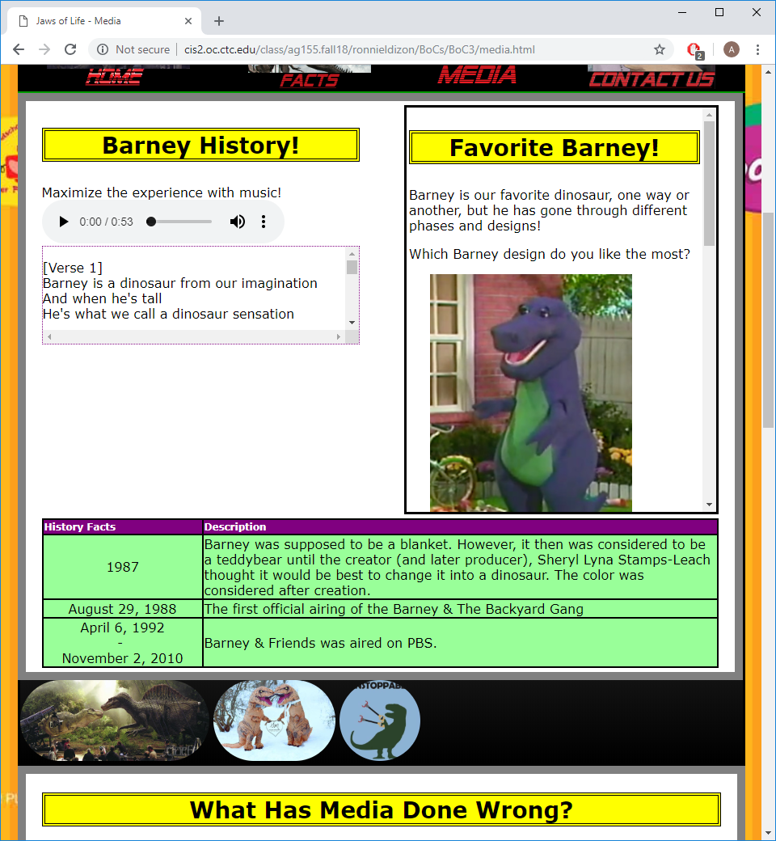

MS Edge

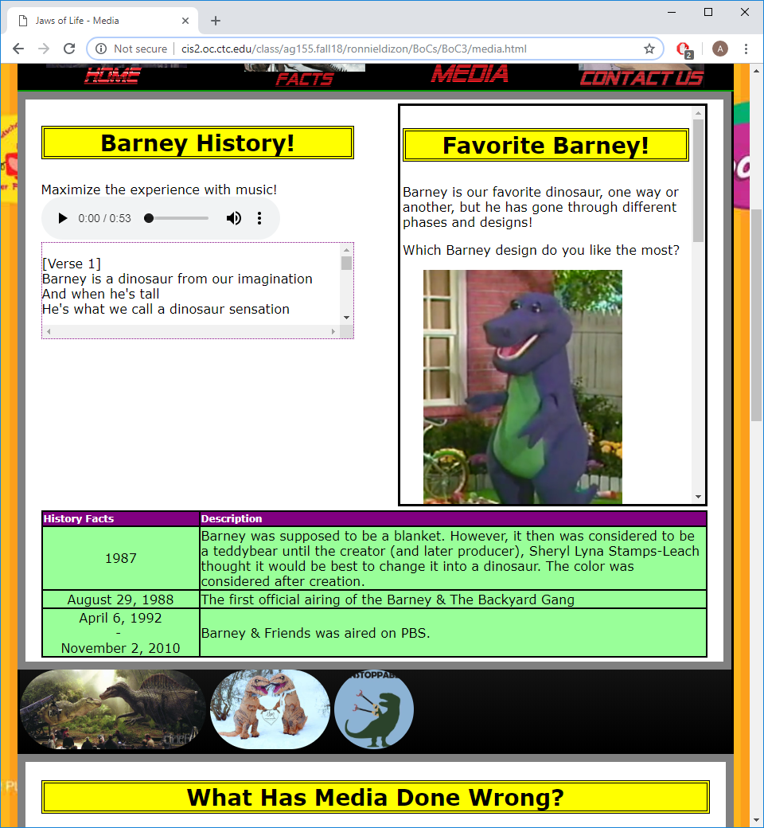

Google Chrome